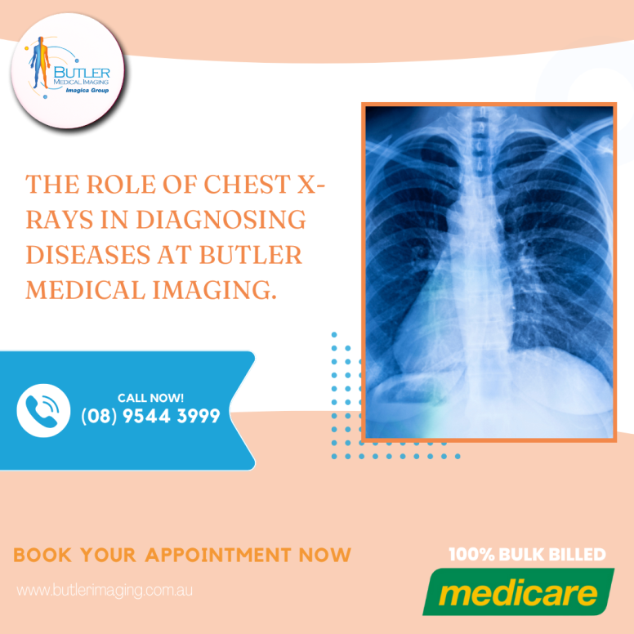The Role of Chest X-rays in Diagnosing Diseases at Butler Medical Imaging. (08) 9544 3999

Chest X-rays are a fundamental tool in medical diagnostics, providing essential images of the heart, lungs, blood vessels, airways, and the bones of the chest and spine. They are instrumental in diagnosing a range of conditions, from heart problems and lung infections to fractures and tumors. Let's explore the critical role chest X-rays play in diagnosing diseases and the numerous benefits they offer.

# Why is a Chest X-ray Done?

Chest X-rays are among the most common imaging tests used by healthcare providers. They are often the first [diagnostic tool](https://crystalradiology.com.au/x-ray/) used when a patient presents with symptoms such as chest pain, shortness of breath, or a persistent cough. Here are some of the primary reasons a chest X-ray might be ordered:

**Heart-Related Lung Problems:** Chest X-rays can reveal changes in the lungs due to heart conditions. For example, congestive heart failure can cause fluid buildup in the lungs, which is easily detectable on an X-ray.

**Lung Condition:** X-rays can identify lung infections, cancer, or air around a lung that can cause it to collapse. They are also effective in [diagnosing chronic lung](https://crystalradiology.com.au/x-ray/) conditions like emphysema and cystic fibrosis.

**Heart Size and Shape:** An enlarged heart or changes in heart shape can indicate heart failure, fluid around the heart, or valve issues.

**Blood Vessels:** The main blood vessels near the heart are visible on a chest X-ray, helping to diagnose aortic aneurysms, other vessel issues, or congenital heart disease.

**Postoperative Monitoring:** After surgery on the heart, lungs, or esophagus, chest X-rays are used to monitor recovery and check for complications such as air leaks or fluid buildup.

**Calcium Deposits:** X-rays can detect calcium in the heart or [blood vessels](https://crystalradiology.com.au/x-ray/), indicating damage to the heart or presence of healed infections.

**Fractures:** They help in identifying fractures in the ribs or spine, providing crucial information for treatment.

**Medical Device Placement:** For patients with pacemakers, defibrillators, or catheters, X-rays ensure these devices are correctly positioned.

# When Do You Need a Chest X-ray?

A chest X-ray is typically requested if you present with symptoms that may indicate chest or lung problems, such as:

* Chest pain
* Persistent cough
* [Fever](https://crystalradiology.com.au/x-ray/)
* Shortness of breath

These symptoms can be indicative of various conditions, from infections and lung diseases to heart problems and fractures.

# How to Prepare for a Chest X-ray

Preparation for a chest X-ray is minimal:

**Procedure:** The X-ray is taken in a specialized room with a movable camera on a metal arm. You will be asked to stand next to a plate that either contains X-ray film or a sensor that [records images](https://crystalradiology.com.au/x-ray/) digitally.

**Positioning:** The technician will position you to capture both front and side views of your chest. You will need to hold your breath while the images are taken to ensure clarity.

**Painless Process:** The procedure is painless and quick, typically taking about 20 minutes. You may be asked to remove jewelry and wear a hospital gown.

# Understanding the Results

A chest X-ray provides a black-and-white image of your internal structures. Denser areas, like bones and the heart, appear white, while air-filled spaces like the lungs appear darker.

**Bones:** Dense and appear white.

**Heart:** Appears as a lighter area.

**Lungs:** Air-filled and appear darker.

A radiologist will examine the images for signs of [heart failure, fluid](https://crystalradiology.com.au/x-ray/) around the heart, infections, malignancies, or other abnormalities. Your doctor will discuss the findings with you during a follow-up appointment.

# Conclusion

Chest X-rays are a vital diagnostic tool in modern medicine. They offer a non-invasive, quick, and painless way to get detailed images of the heart, lungs, and chest bones, facilitating early diagnosis and effective treatment of various conditions.

# Why Choose Butler Medical Imaging?

At [Butler Medical Imaging](https://butlerimaging.com.au/appointment), we are a local and privately-owned medical clinic offering the highest quality medical and imaging services. We are leaders in Bulk Billing, providing the real benefit of no ‘Out-of-pocket’ expenses for our patients. Our commitment to accuracy, professionalism, convenience, and patient care sets us apart.

# [Your Next Step](https://butlerimaging.com.au/appointment/)

To get started with your ultrasound-guided injection, please ensure you have your Medicare card and referral with you and visit our location for a consultation. If you have any questions, feel free to contact us at [+61 8 9544 3999](https://butlerimaging.com.au/appointment/). We are here to help you on your journey to pain relief and better health.